

|  |  |  |  |  |  |  |  |  |
| --- | --- | --- | --- | --- | --- | --- | --- | --- |
|  | | | | | | | | |
|  | | PROJECT REPORT | | | | |  | |
|  |  | | | | | | |  |
|  | | | |  |  | | | |
|  | | | |  |  | | | |
|  | | | | HERITAGE INSTITUTE OF TECHNOLOGY, KOLKATA—**Design and Optimization of Nearest Neighbor Based Quantum Circuits** PROJECT GROUP – B65 SUBMITTED BY:Subhadeep Rakshit (2151205) **Sayak Samanta (2151181)**  **Tithendu Bhowmick (2151178)**  **Subham Kumar Shaw(2151179)**  **PROJECT GUIDE – ANIRBAN BHATTACHARJEE** |  | | | |
|  | | |  | | |  | | |

**INTRODUCTION**

The advent of quantum computing has ushered in a new era of computational possibilities, enabling solutions to complex problems that are intractable for classical computers. Among the various quantum algorithms, the Nearest Neighbor (NN) algorithm holds significant promise for applications in fields such as machine learning, optimization, and data analysis. However, the practical implementation of NN-based quantum circuits presents several challenges, particularly concerning circuit design and optimization.

This project aims to explore the design and optimization of NN-based quantum circuits, focusing on enhancing their efficiency and scalability. By leveraging the unique properties of quantum systems, we will investigate innovative circuit architectures and optimization techniques that improve performance while minimizing resource requirements. The goal is to develop a framework that not only simplifies the design process but also maximizes the computational power of quantum circuits.

In this context, we will examine key factors influencing circuit performance, including gate fidelity, qubit connectivity, and noise resilience. Through a combination of theoretical analysis and practical experimentation, this project will contribute to the ongoing quest for more efficient quantum algorithms, paving the way for their real-world applications. Ultimately, our findings aim to advance the field of quantum computing by providing insights into the design principles that govern NN-based quantum circuits, enhancing their utility in solving complex problems across various domains.

**PROBLEM STATEMENT**

To enhance the efficiency and scalability of Nearest Neighbor-based quantum circuits using Python by optimizing circuit design and improving gate fidelity.

**MOTIVE AND CONTRIBUTION**

The motive of this project is to bridge the gap between theoretical quantum algorithms and their practical implementations by optimizing Nearest Neighbor-based quantum circuits. As quantum computing continues to evolve, efficient circuit design becomes crucial for harnessing its full potential. By focusing on enhancing performance metrics such as gate fidelity and qubit connectivity, we aim to facilitate real-world applications in machine learning and optimization. Ultimately, this project aspires to contribute to the broader adoption of quantum technologies, making complex problem-solving more accessible and effective.

We have utilized python as a tool to design appropriate algorithms for optimizing the qubits in the quantum circuits. We are developing the algorithms on Google Colab such that we can minimize the cost required and enhance their efficiency and scalability. We are still developing and continuing the project upon the next semester. The progress of our project can be seen in the Google Colab link given below:

https://colab.research.google.com/drive/19njiNrADAI1Whc1Gxct9Usd42u3LX_mp?usp=drive_link

**LITERATURE SURVEY**

We had taken help of our mentor and studied different research papers on the topic. Some of the concepts are explained below: -

* A quantum circuit is a model for quantum computation that consists of a sequence of quantum gates applied to a set of qubits. Each gate represents a specific operation that manipulates the qubit states, allowing for the implementation of quantum algorithms. Quantum circuits are visually represented as diagrams, with qubits represented as horizontal lines and gates as symbols acting on these lines over time, enabling the execution of complex quantum processes

.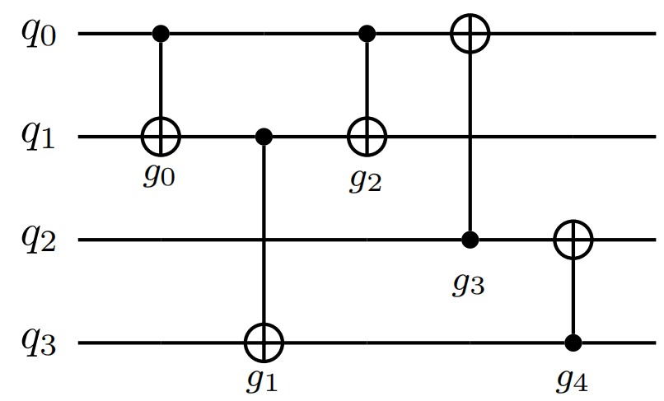

* Swapping a gate refers to the process of exchanging the positions of two quantum gates within a quantum circuit. This is often done to optimize circuit layout, improve gate connectivity, or reduce the overall circuit depth. In the context of quantum computing, swapping gates can enhance the performance of quantum algorithms by allowing qubits that are not directly connected to interact through intermediate operations, thereby facilitating more efficient computation.

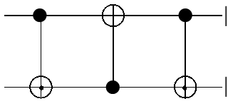

* Swapping of gates can be used as a naive approach to find the nearest neighbor in a quantum circuit by rearranging gate operations to ensure that qubits involved in nearest neighbor interactions are physically adjacent. This allows for more efficient execution of quantum gates, minimizing the need for additional operations or resources to connect distant qubits. By iteratively swapping gates, we can optimize the circuit layout for better performance in nearest neighbor searches.
* Global Reordering refers to a method of rearranging all the gates in a quantum circuit simultaneously to optimize the overall circuit structure. This approach aims to minimize the total circuit depth and resource usage by considering the entire circuit, ensuring that qubits involved in operations are effectively placed for optimal connectivity and performance.
* Local Reordering, on the other hand, focuses on adjusting the arrangement of gates within a limited scope, typically involving only a small section of the circuit. This method allows for quick optimizations by rearranging gates that are in close proximity, improving gate interactions and reducing overhead without affecting the entire circuit structure. Local reordering can be particularly useful for enhancing specific areas of a circuit while maintaining overall coherence.
* The look-ahead method is an optimization technique used in quantum circuit design that anticipates future gate operations to improve current decisions about gate placement and connectivity. By evaluating the effects of potential future gates on the current circuit layout, this method allows for better rearrangement of gates, optimizing qubit usage and reducing circuit depth. This proactive approach helps to minimize the need for additional swaps or overhead, ultimately enhancing the performance of the quantum circuit.

**PROPOSED METHOD**

We have decided to collaborate together as a team to design some algorithm using python in Google Colab, such that it can effectively reduce cost of the circuit in finding its nearest neighbor and work efficiently. We have tried to use the explained concepts given above effectively such that it can help us create an algorithm and improve the working of it. In the Google Colab we have first started by reading the given file which consists of the circuit given in csv format. Then we have extracted out the required rows and allotted time to the gates in places that they exist on the qubit.

We have then printed the adjacency matrix which shows the number of connected qubits to each other via the gates which will be required later on. Then we have calculated the edge weights of the qubits using a formula that is proposed by us and then arranged them according to their priority. Finally, we have put them in a matrix in a defined pathway (up, right, left, down, left) selected by us. Now we just have to place the qubits in such a way that they are using the least cost to connect to each other with the help of this matrix which is a work in progress and will be continued until the next semester.

**END**